LAB Logbook

Lab 1
My Sid = 2560883
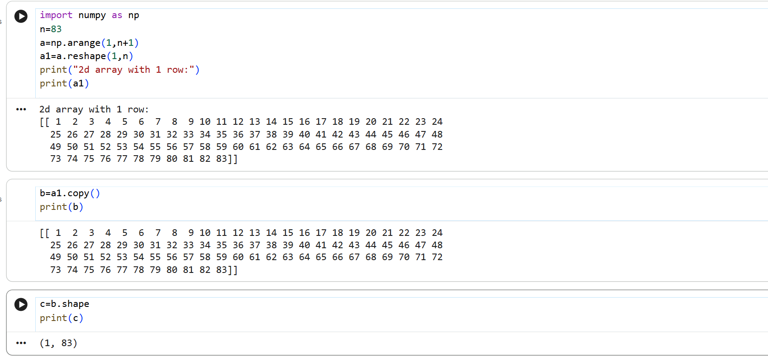

Lab2
My Sid = 2560883
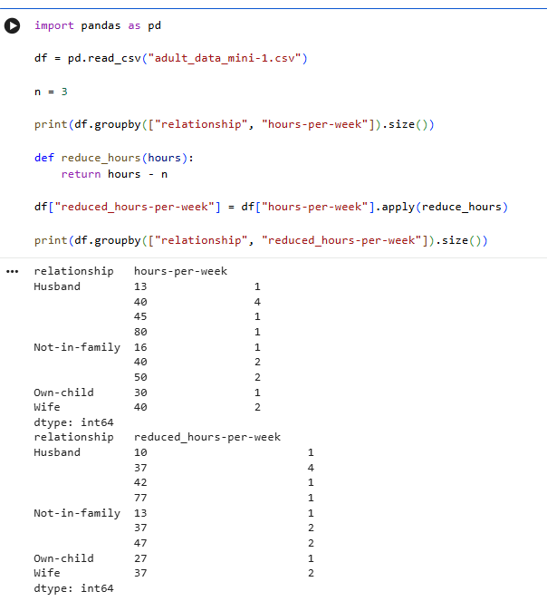

Lab 3
My Sid = 2560883
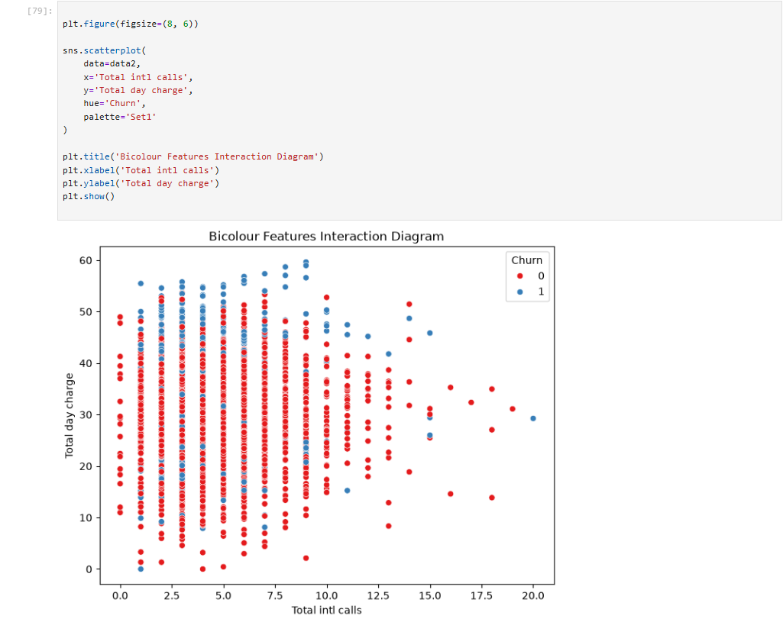

Lab 4 - My Sid = 2560883
MLP Architecture
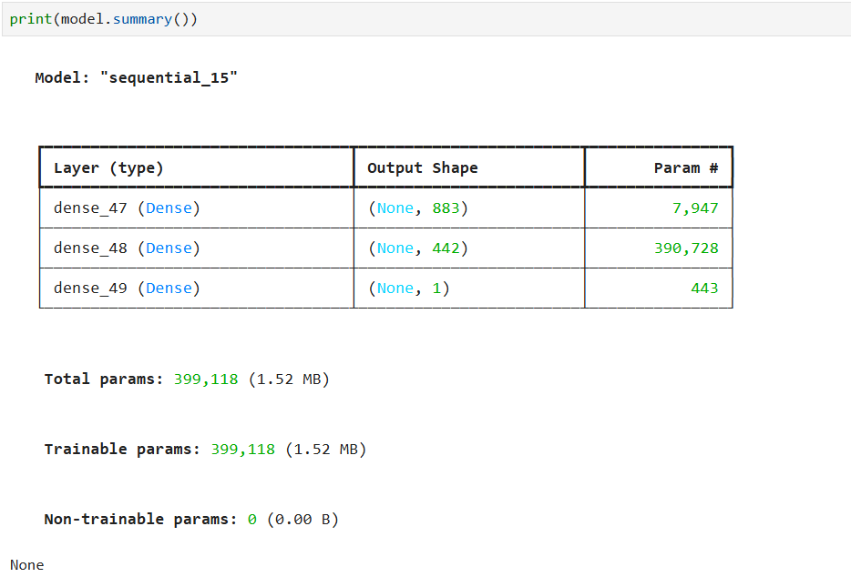
MLP Training
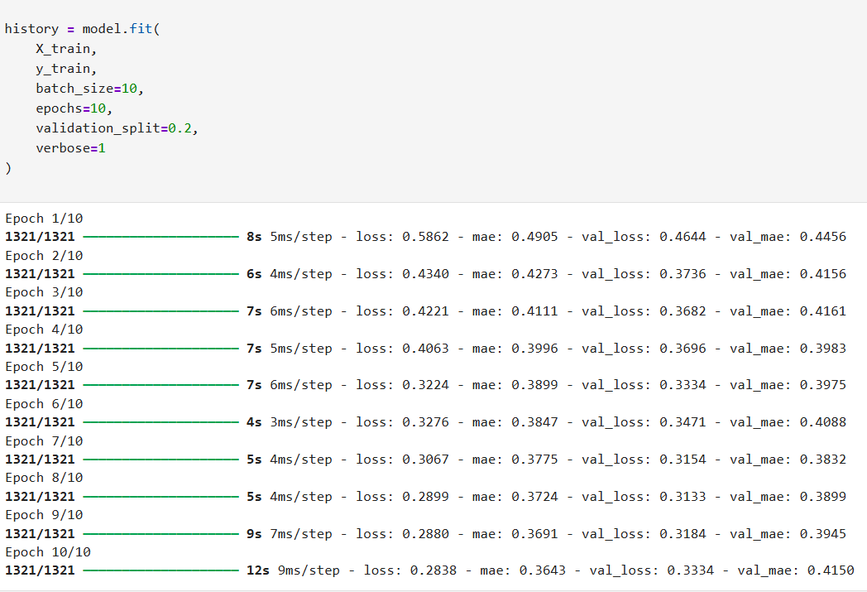
Evaluation
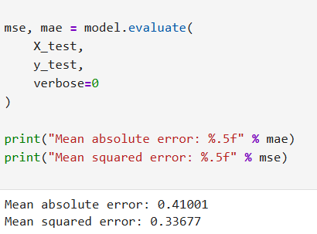

Lab 5 - My Sid = 2560883
CNN Architecture
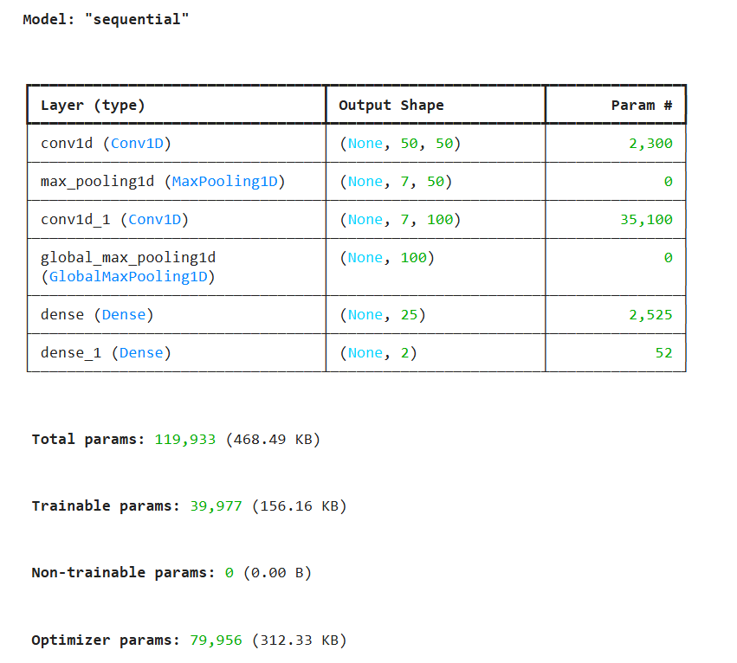
CNN Training
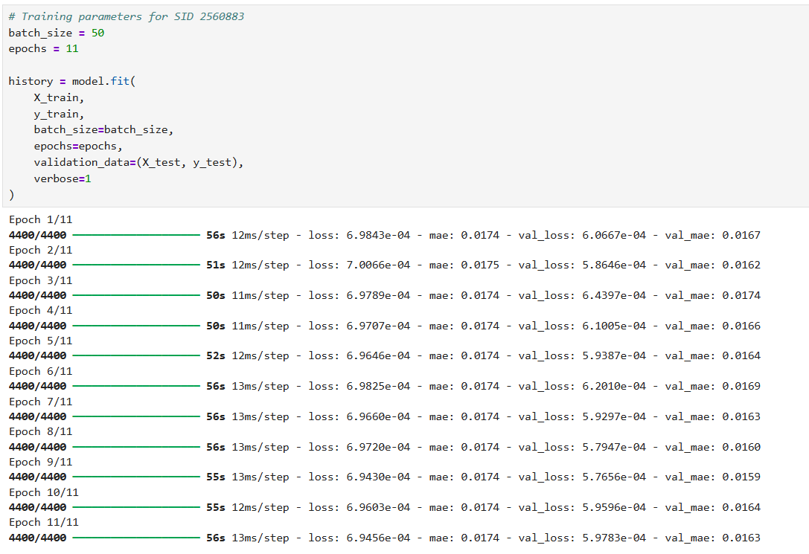
Test MAE
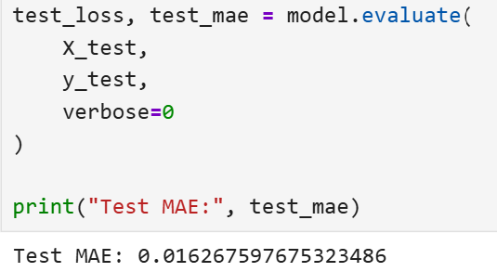

MAE Histogram
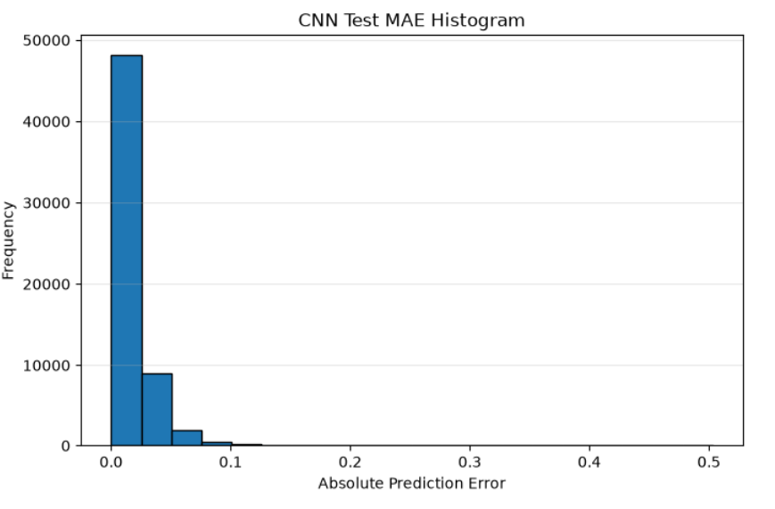

Comparison of the Two MAE Values
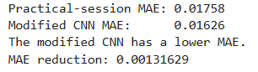

Lab 6
My Sid = 2560883
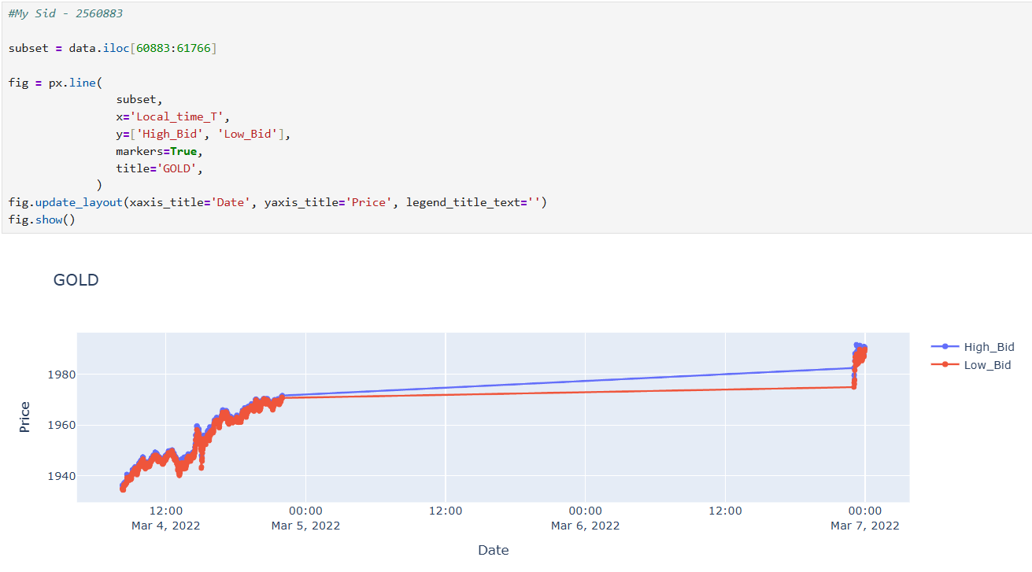

Lab 7
My Sid = 2560883

LSTM architecture
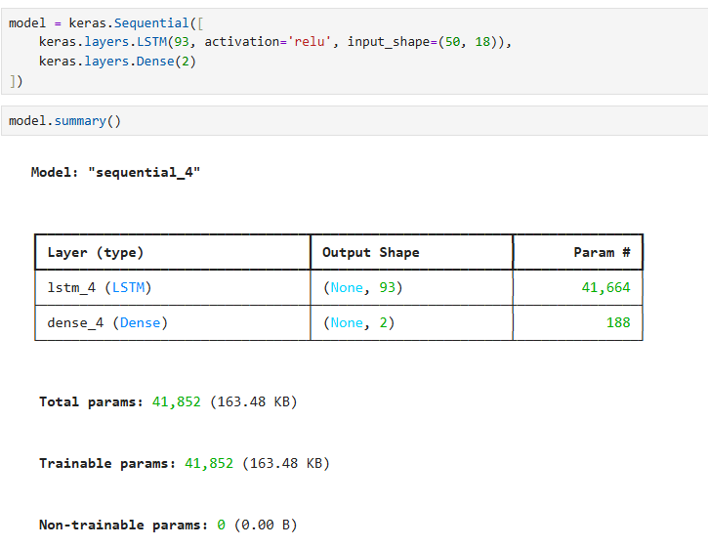

Training process
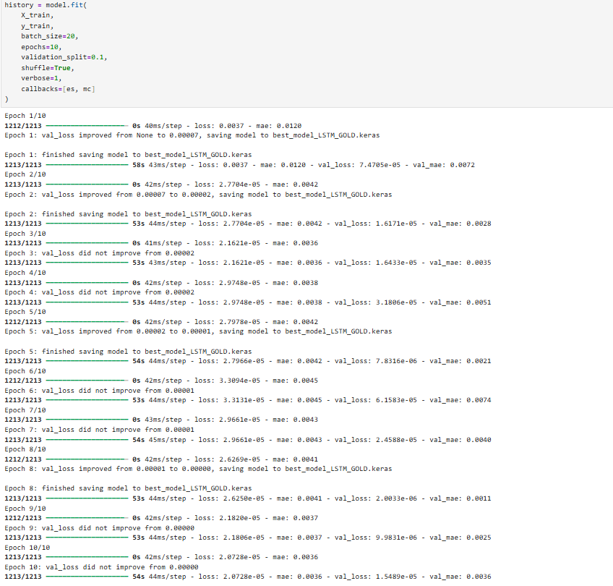

Test MSE & MAE
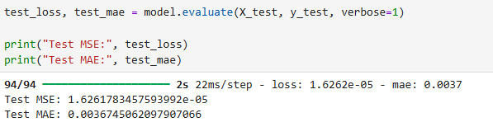

MAE Graph
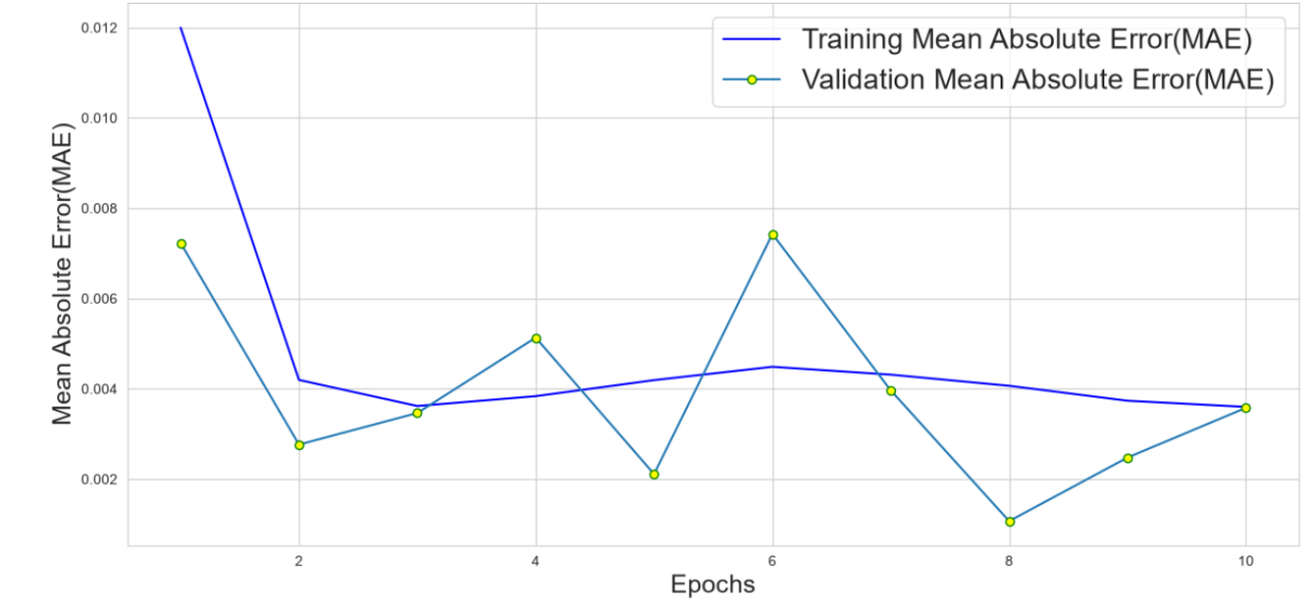

Lab 8
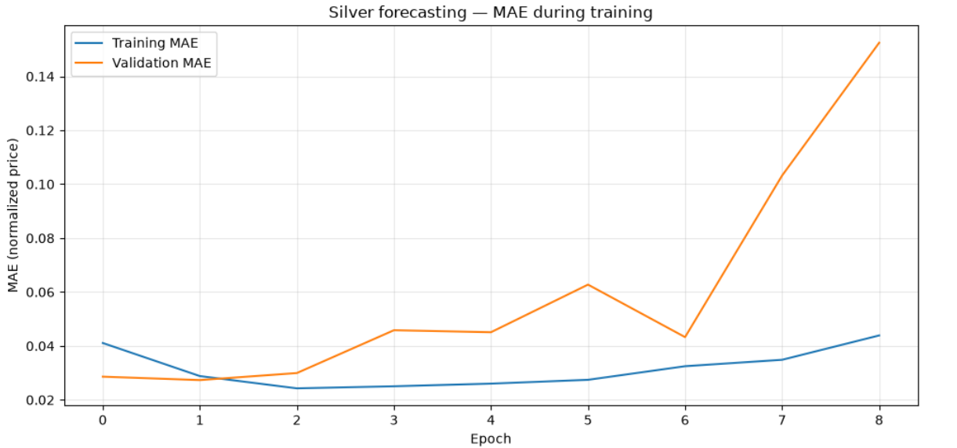

Lab 9

Lab 10

Lab 11

Lab 12

